Factors influencing the persistence of created tidal marshes in the

Fraser River Estuary, British Columbia

**Authors:**

Daniel Stewart, Daniel Hennigar, Robyn Ingham, Eric Balke

January 2022

# Acknowledgements

This report was made possible through the B.C. Wildlife Federation Wetlands Workforce project which was funded by the provincial Healthy Watersheds Initiative program. Data collected in 2015 was facilitated by the Community Mapping Network and B.C. Conservation Foundation and funded through the National Wetland Conservation Fund. We also wish to thank the Community Mapping Network for hosting compensation site data on their BIEAP-FREMP Atlas, as this was an essential starting place for both 2015 and 2021 surveys.

The authors extend thanks to landowners who allowed entry to compensation marshes during 2015 and 2021 surveys. This includes Metro Vancouver Regional District, the Vancouver Fraser Port Authority (VFPA), Vancouver Airport Authority, Pacific Custom Logistics, Ladner Yacht Club, S&R Sawmills Ltd., Blue Heron Marina Estates, and the B.C. Ministry of Forests, Lands, Natural Resource Operations and Rural Development (MFLNRORD).

With gratitude we wish to acknowledge the time and expertise offered by reviewers of this report. These include Gary Williams (G L Williams & Associates Ltd.), Mark Adams (Envirowest Consultants Inc.), Krista Forysinski (Fisheries and Oceans Canada), Robert Sambrook (Fisheries and Oceans Canada), Yeganeh Asadian (xʷməθkʷəy̓əm [Musqueam] Indian Band), Shane Byrne (MFLNRORD), Vanessa Koo (VFPA) and Charlotte Olson (VFPA).

# Abstract

More than 100 tidal marsh creation projects have been constructed in the Fraser River Estuary, British Columbia, Canada, from the 1970s to present. Though these projects share similar habitat creation goals, they differ in their respective designs and environmental contexts. Past studies described and evaluated many of these projects and found varied success, but the underlying factors that determine their outcomes have not yet been formally investigated. Using a combination of field sampling, remote sensing, and statistical modeling, we aim to address this knowledge gap by asking what factors determine (1) if created marshes remain vegetated, and (2) the resilience of created marsh plant communities. We observed recession in 37 of the 79 created marshes visited, representing losses of 22,946 m2 of the 231,092 m2, or 9.9%, of habitat surveyed. Protective infrastructure, specifically debris fencing and offshore structures such as marina docks and log storage booms mitigated recession. Sites built in the North Arm averaged 18% more recession than those in the wider South Arm, which may be attributed to higher wave energy. Sites that were lower in elevation and contained higher proportions of edge habitat were more vulnerable to recession than high elevation sites. Dominance of native species declined at a rate of 1% per kilometer upriver. Invasive cattail defied this trend, dominating many of the outer estuary sites in which it occurred. Native and non-native plant species richness shared similar trends across the estuary, increasing with elevation and distance upriver. These findings offer insight into the role that site design and location play in the outcome of marsh creation projects, and the potential challenges posed by environmental change in the estuary.

# Introduction

Human settlement has occurred in estuaries for millennia as they contain productive airable land and abundant natural resources, and are in close proximity to the ocean (Small & Nichols 2003; Fitzpatrick et al. 2015). The result, particularly in recent centuries as human populations have exponentially increased, has been the escalated alteration, fragmentation, and loss of estuarine habitats around the world. These losses have led to declines in the function, services, and resilience of these ecosystems in an age in which threats such as climate change, sea-level rise, and species invasions abound (Dahl 1990; Vitousek et al. 1997; Barbier et al. 2011; O’Meara et al. 2017). To this day, habitat loss continues to be one of the major threats to global estuaries, as coastal human populations continue to increase (Kennish 2002).

Estuaries along the Pacific coast of North America have not been immune to these losses. Brophy et al. (2019) estimated that 85% of vegetated tidal wetlands have been lost from estuaries along the contiguous U.S. Pacific Coast, with the greatest losses occurring in major river deltas. The Fraser River delta, the largest estuary on Canada’s Pacific Coast, has seen similar wetland losses, estimated between 70–90% since European settlement (Hoos & Packman 1974; Boyle 1997). In addition to ecosystem services, these losses are detrimental to many species that depend on these habitats, including spatially-restricted plant species such as Henderson’s checker-mallow (*Sidalcea hendersonii*) and Vancouver Island beggarticks (*Bidens amplissima*), and declining Pacific salmon populations that use tidal marshes as foraging and refuge habitat during juvenile life stages (Magnusson & Hilborn 2003; Bottom et al. 2005; Chalifour et al. 2019, 2021). The north-south network of estuaries along the Pacific Coast also provides critical stopover points for migratory bird species travelling along the Pacific Flyway, and productive foraging, resting, and roosting habitat for migratory and resident waterfowl, shorebirds, songbirds, and gulls (Butler & Campbell 1987; Sutherland et al. 2013).

As awareness around the impacts of human activities in estuaries have increased, so too have efforts to counteract them (Broome et al. 2019). In the Fraser River Estuary (FRE), tidal marsh creation projects began in the 1970s but escalated with the introduction of the 1986 *Policy for the Management of Fish Habitat*, which contained guidelines for achieving no net loss (NNL) of the productive capacity of fish habitats in Canada (DFO 1986; Adams & Williams 2004; Bradford et al. 2017). According to the Policy guidelines, unavoidable fish habitat losses[1] would henceforth be balanced by habitat replacement on a project-by-project basis. The primary means of offsetting these losses and achieving NNL was habitat compensation, which depended on the creation of marsh habitats to offset unavoidable losses. Marsh creation projects continue to be proposed and approved in the FRE under the current *Fisheries Act* and Fish Habitat Protection Policy Statement (2019), but differ in no longer adhering to past NNL guidelines, and the term “compensation” has been replaced by “offsetting” (Bradford et al. 2017; DFO 2019). Within this regulatory context over 100 compensation or offset projects were completed in the FRE from the 1980s to 2021, representing nearly all attempts at tidal marsh habitat creation in the region to date.

A small number of reports have documented and even evaluated the functioning of these marsh creation projects, each suggesting that success was not universal. In summer of 1992, Kistritz et al. (1992) noted that some habitat compensation sites were degraded by erosion and driftwood accumulations, likely due to ineffective shear booms or erosion protection. Based on created project area, Kistritz (1995) found that a net gain of brackish marsh habitat occurred in the FRE from 1983 – 1992 due to compensation activities; however, follow-up remediation was still recommended at a number of failed sites. Levings and Nishimura (1996) compared the functioning of transplanted, natural (reference) and disrupted (unvegetated) marshes in the FRE and found that the average percent cover of Lyngbye’s sedge (*Carex lyngbyei*) in created tidal marshes sites was less than 50% of that observed in reference sites, while transplanted sites had overall higher rush (*Juncus* spp.) cover. Invertebrate abundance was also compared and was frequently higher in created marshes than reference marshes. Although no differences were found in Chinook salmon (*Oncorhynchus tschawytscha*) and chum salmon (*O. keta*) fry among sites, smolt catches were significantly different, with often higher catches at disrupted sites. Adams and Williams (2004) provided a more recent summary of these projects, noting that early marsh-creation efforts were more prone to failure, likely due to inappropriate species selection and poor quality assurance during site preparation and planting. Lievesley et al. (2016) evaluated a subset of FRE projects based on vegetated area and native plant dominance, though these were not the criteria by which these projects were assessed by regulators. They found that of the 54 marshes visited in their study, 65% achieved their intended vegetated marsh area, and 50% of sites possessed marsh vegetation comparable in native dominance to neighbouring reference sites.

These reports have described in detail the status of created tidal marshes, but to our knowledge no research has attempted to investigate the mechanisms behind their success or failure in the FRE. One of the challenges to such an investigation is definingproject “success”, as this word is imprecise, often controversial in ecology, and the definition can vary among organizations and individuals (Kentula 2000; Zedler & Callaway 2000). This disunity is further compounded by a lack of standardized monitoring protocols in the region, which several authors have already brought to light (Levings 2000; Adams & Williams 2004; Bradford et al. 2017). For the purposes of this report, we deviate from the yes/no terms of “success” or “failure”, acknowledging that even “failed” sites possess ecological values, and instead focus on “resilience”, which we define as the ability of these projects to function and persist as vegetated tidal marshes within the environmental context of the FRE (Zedler & Callaway 2000).

Vegetative cover is commonly used to evaluate created tidal marshes, and is a success metric employed in FRE monitoring programs (Kentula 2000; Zedler & Callaway 2000; Adams & Williams 2004; Broome et al. 2019). Functioning tidal marshes support high levels of net primary production (NPP), that over time accumulates in the form of soil organic matter. This organic surface soil horizon is an integral part of the detritus-based food web of estuaries. For this reason, as well as refuge offered by aboveground biomass, vegetative cover has historically been used as a proxy for high-quality fish habitat in the region (Levings 2004a; Bradford et al. 2017). In addition to providing food and refuge for numerous other species, tidal marshes provide a multitude of ecological services, including soil stabilisation, water quality maintenance, wave attenuation, carbon sequestration, and nutrient cycling (e.g., Peterson et al. 2008; Broome et al. 2019; Forysinski 2019; Arias-Ortiz et al. 2021; Correa et al. 2021).

Species composition can greatly influence the ecological functions and services of a plant community (e.g., Haines & Hanson 1979; Jessop et al. 2015; Alldred & Baines 2016; Forysinski 2019). The abundance of invasive species is regularly used to monitor site function, as they can displace native flora over large areas, and may subsequently alter the structure, biodiversity, productivity, and food webs of wetlands (Zedler & Kercher 2004). Though few in number, studies that have investigated the effects of invasive species in the FRE support this. D are known to beLyngbye’s sedge (*arex*), (Grout et al. 1997) Non-native cattail, especially hybrid *Typha ×* *glauca* currently occupies an estimated 4% or 500,000 m2 of tidal marsh habitats in the FRE, forming near monocultures where established. This ongoing cattail invasion may represent a major disruption to biodiversity and food web interactions in the FRE, as monocultures are significantly less floristically diverse, and contain fewer chironomids and overall benthic invertebrates than nearby sedge meadows (Lee 2021; Stewart 2021).

Diversity is another metric of composition that may offer insights into the resilience and functioning of a tidal marsh (Levings 2004b). Diverse plant communities have been shown to be more temporally stable, higher functioning, and potentially more resilient to environmental change than less diverse ones (Tilman 1997; Naeem 1998; Allan et al. 2011), but not necessarily an increase in services (Jessop et al. 2015). How these ecological concepts translate to the delta front, where salt and inundation stress are highest and only a small number of species can exist, is uncertain. However, for the remainder of the estuary, it is likely that richness plays a role in the value, function, and long-term resilience of created marsh communities.

A second obstacle to investigating the mechanisms behind the resilience of these projects is the complexity of such an analysis, which requires consideration of the design, environmental context, and regulatory measures of a given project. Project designs vary considerably in the FRE from elevated marsh benches, to dike breaches, to embayments, each differing in size, shape, elevation, age, planting prescription, and degree of protection from debris and erosion. Each site also occurs in a unique environmental context, being influenced by a combination of abiotic (e.g., saltwater influence, tidal influence, debris accumulation) and biotic factors (e.g., herbivory, invasive species), that vary based on location in the estuary, and elevation. The regulatory environment of each project is also unique, and based upon measures committed to by proponents in their respective *Fisheries Act* Authorization applications. These measures were then accepted and later approved by Fisheries and Oceans Canada (DFO) after a determined monitoring period. In general these measures have become more robust over time, which has contributed to the success of many more recent projects (Adams & Williams 2004; Levings 2004b).

The objective of this study was to advance our understanding of marsh habitat creation and management in the FRE by learning from the successes and failures of over 40 years of projects. This is motivated by a recent surge of interest among stakeholders in the estuary to build new habitats and enhance past projects. Examples of such initiatives include an upcoming large-scale dike breach in the Alaksen Wildlife Area (Ducks Unlimited Canada), tidal marsh creation with the upcoming Iona Wastewater Treatment Plant upgrades (Metro Vancouver Regional District), and prioritisation planning for the enhancement of past projects (Fisheries and Oceans Canada, Ducks Unlimited Canada). To achieve this, we used a combination of field sampling, remote sensing, and statistical analyses to investigate key factors that contribute to the outcome of projects. Specifically, we asked:

1. What factors are associated with marsh recession in created tidal marshes?
2. What factors determine the dominance of native species in created tidal marshes?
3. What factors are associated with plant community diversity in both created and natural tidal marshes?

# Methods

## Field Sampling

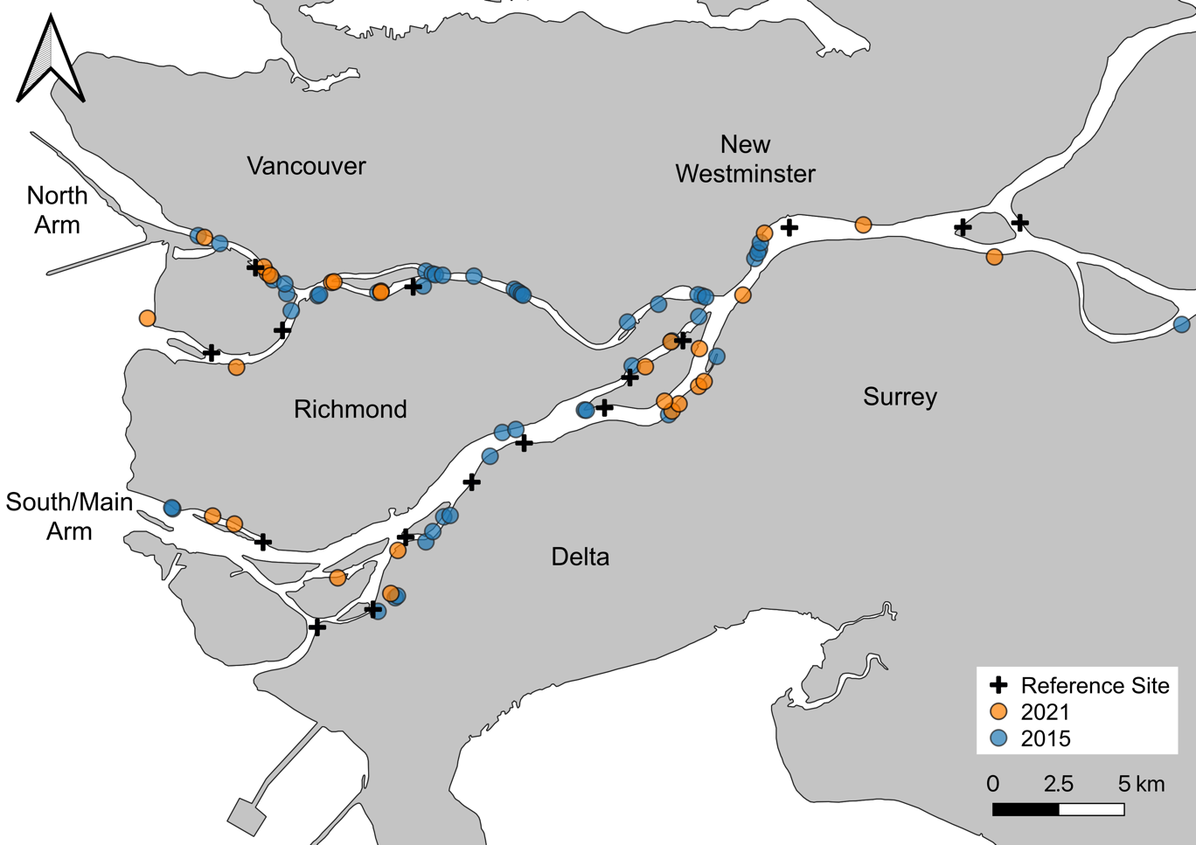This study includes data from 79 marsh creation projects and 16 reference marshes located in the Fraser River Estuary, southwest British Columbia (Fig. 1). Among these are 51 projects and 7 reference sites surveyed in 2015 by Lievesley et al. (2016), whose data we include and build upon with an additional 28 projects and 9 reference sites surveyed in summer 2021. Wetland reference sites may vary selection criteria depending on study objectives (Kentula 2000), and for the purposes of this report we define reference sites as tidal marshes that to our knowledge were not significantly disrupted by human activity in recent decades, and were not constructed (see Appendix A for reference site details). Many of the marsh sampling methods presented here were adapted from Lievesley et al. (2016) to maintain consistency between datasets.

Figure 1. Map of assessed marsh habitat compensation projects and reference marshes in the Fraser River Estuary (2021: *n* = 38; 2015: *n* = 58; total *n* = 96). Base map: 2016 Canadian Census Boundaries, Statistics Canada.

Created tidal marshes were located using a combination of desk-based and field-based reconnaissance, correlating project descriptions and photographs provided in the BIEAP-FREMP Atlas with field observations and imagery (CMN 2021). Randomized sampling plots were generated in advance of site visits using a random plot generator in QGIS (3.20, QGIS Development Team 2021), with all plots separated by at least 3 m. We targeted an optimum sample size of 20 plots per site (James-Pirri et al. 2007), though occasionally fewer were sampled due to tide/time constraints, or in cases where sites were too small to contain the target number of plots. Each plot entailed a 1 x 1 m quadrat oriented perpendicular to the nearest major channel, typically the Fraser River. Surveyors recorded the aerial percent cover of all living macrophytes originating from within the quadrat, as well as exposed substrates (i.e., litter, mud, rock, debris). Percent cover estimates were permitted to exceed 100% in cases where foliar cover of species overlapped significantly. Each species was then classified into one of four origin classes: native, introduced (invasive), introduced (non-invasive), and unknown. No definitive invasive species list exists for the FRE, so we classified species that (1) are listed as noxious weeds under the *Weed Control Act* Regulation and (2) align with the prevailing definition of invasive species[2] based on our professional judgement. Plot data were then used to calculate species richness and relative percent cover data for each plot. Relative percent cover is defined as the cover of a given species or grouping of species as a percentage of the total plant cover in a plot and was used to account for seasonal bias in our sampling, and high variability of plant forms and densities in our study area.

In addition to vegetation sampling, we mapped the boundary of each marsh creation project using a combination of handheld GPS units (Garmin GPSMap® 64s) and Apple iPad mini (5th generation) with Avenza Maps mapping software and 10 cm resolution georeferenced imagery (3.14.1; Avenza Systems Inc. 2021). Vegetated areas, unvegetated mudflats, and log debris accumulations within the intended marsh area were also mapped. While mapping, we also noted the presence of debris fences, functional foreshore shear booms, and other structures (i.e., docks, log storage booms) located immediately offshore.

## Geospatial Data

Geospatial analyses were used to describe the condition and environmental context of plots and sites. Project area was calculated based on polygons mapped in the field and was defined as the marsh boundary of a given project. Where original project descriptions, design schematics, or photographs were available, these were also used to aid in delineating site boundaries. We found that most created marshes visited in this study had clear and obvious boundaries (e.g., rip-rap perimeter), and thus we are confident in the calculated project areas. We calculated the percent of recessed marsh in each project by dividing the area of recessed marsh mapped in the field by the total project area. For the purposes of this study, recessed marsh was defined as areas within tidal marsh creation projects that were intended to be vegetated in their original design but were primarily absent of vegetation during 2015 or 2021 surveys (see inset right; see Appendix B for photo examples). We calculated percent edge habitat for each site by using the Measurement Tool in QGIS to calculate the area of marsh located within 5 m of the river channel, which we then divided by the project area. Each site was assigned a distance from the river mouth, which was calculated as the channel-distance from each site to a standardized line across the mouth of the Fraser. In cases where multiple pathways to the river mouth were possible, distances were based on those of the largest, and therefore most influential, channel. Elevation data from a publicly available LiDAR dataset was used to calculate both mean site elevation, and sample plot elevation in QGIS (GeoBC, 2021). For each sample plot, proximity to channel was calculated in QGIS using the GRASS Toolbox (7.8.6; GRASS Development Team 2012).



***Recession in Created Marshes***

We defined marsh recession as areas within tidal marsh creation projects (red line above) that were intended to be vegetated in their original design but were primarily absent of vegetation during 2015 or 2021 surveys (e.g., area between red and yellow lines above). Engineered tidal channels and intertidal mudflats were not included in recession estimates. To ensure the accuracy of these estimates, we referred to a combination of available historical imagery, site plans, monitoring reports, and photos to delineate planted areas. As visualised in the photo above, these recessed areas were often located along the foreshore, where the effects of adverse factors such as wave erosion and goose herbivory were most pronounced.

## Statistical Analysis

### Marsh Recession

We used multiple linear regression models in R to determine which factors influence marsh recession in created marshes (lm, ‘stats’ package in R; R Core Team 2021). Percent recessed marsh was used as the dependent variable, and model covariates were selected for their potential relationship to marsh recession based on professional judgement and data availability. Covariates included descriptive categorical variables, such as presence of a debris fence (see inset, p. 8), presence of a shear boom, presence of offshore structures (i.e., log storage booms, dock structures), inland design (see inset left; Appendix B), and river arm. Numeric covariates included project age, project area, distance upriver, percent edge habitat, and mean site elevation. An interaction term was included between mean site elevation and percent edge habitat, as we anticipated that the degree of edge effects on our response variables was highly dependent on project elevation. For a more detailed description of each model variable, see Appendix C.

### Native Dominance

To determine which factors influence the dominance of native species in created marshes, we modeled the relative % cover/plot of native species using a linear mixed-effects model (‘lmer’, “lme4” package in R; Bates et al. 2015). Sample plot data from created marshes were used for this analysis. Covariates were selected based on data availability, and evidence in the literature of their relevance to plant species distributions in estuaries. Numeric covariates included plot distance upriver (a proxy for saltwater and tidal stress), plot elevation, plot distance to nearest channel, and age of habitat creation site. River arm and inland basin were binary categorical variables. Sample year and sites were included as random effects to account for potential sampling differences between 2015 and 2021 datasets, and to account for site-to-site variation (lmer, ‘lme4’ package in R; Bates et al. 2015). We included an interaction term between both plot distance upriver, and plot channel proximity with elevation, as we anticipated the effect of both covariates on native dominance to be dependent on elevation.

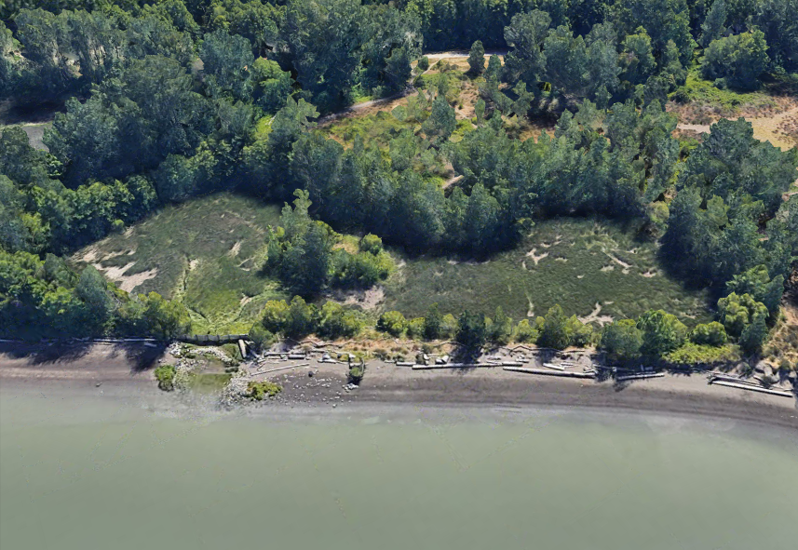

***Embayed Designs***

Sixteen of the 79 compensation sites included in this study were classified as “embayed” designs. These projects are typically excavated behind dikes and are connected to the river via engineered drainage channels, such as the site pictured above (FREMP# 03-004, CPR# 9303-0041). Inland sites vary in size and shape from narrow channels and sloughs to large lagoons. By design, inland sites have very little exposure to external stressors such as erosion and herbivory, but may suffer from other factors such as shading, ponding resulting from poor drainage, and invasive species.

**Outflow**

**Outflow**

### Species Richness

We used linear mixed-effects models to investigate factors that influence native and non-native species richness across the estuary (‘lmer’, “lme4” package in R; Bates et al. 2015). These richness models differed from the native dominance model in that they included plot data from both reference sites and created marshes. As a result, model covariates differed in the addition of a binary categorical to distinguish between reference and created marshes, and the removal of site age as a covariate, since the age of reference marshes could not be estimated. An interaction term between plot distance upriver and elevation was included in both richness models, as we expected the effect of plot distance upriver on richness to be dependent on plot elevation.

All models were evaluated for collinearity using variance inflation factors (VIF; vif, “car” package in R; Fox & Weisberg 2019). No model variables exceeded our VIF threshold of 5.0, indicating no significant collinearity was present (James et al. 2013). Model assumptions and fit were assessed through data visualizations, including residual plots to ensure no obvious patterns were present and quantile-quantile (QQ) plots to ensure approximate normality. Fit was also evaluated using adjusted R2 values for the linear marsh recession model, which evaluates the degree to which a response variable is explained by the model while also accounting for the number of independent variables, and R2 values for the linear mixed effects models were reported using methods described by Nakagawa and Schielzeth (2013) using the “MuMIn” package in R (r.squaredGLMM; Bartoń 2020). All statistical analyses were performed using R version 4.0 (R Core Team 2021).

# Results

## Marsh Recession

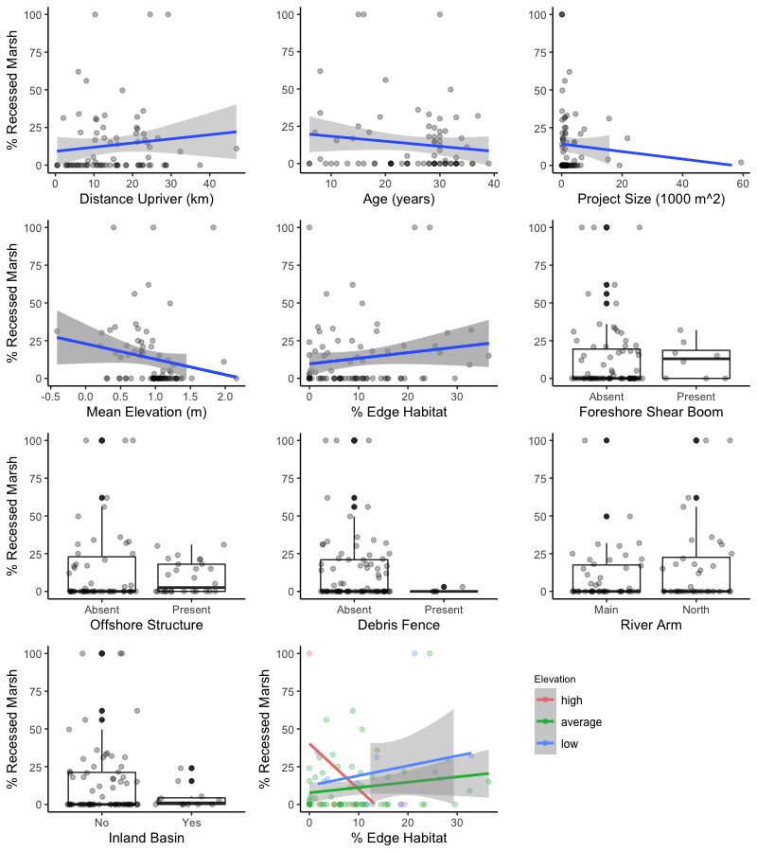Recessed marsh ranged from 0–100% across the 79 created tidal marshes, averaging 13.3% (SD = 22.5%). This equates to approximately 22,946 m2 or 9.9% of the 231,092 m2 of created tidal marshes sampled. Three sites (4%) were entirely unvegetated mudflat, while 42 (53%) had no observable recession. Sites varied considerably in their numeric variable ranges: distance upriver (0.4–46.9 km), age (6 –39 years), size (20 –59,309 m2), mean elevation (-0.41–2.16 m) and proportion of edge habitat (0.0–36.4%; Fig. 2).

Figure 2. Scatter plots and box and whisker plots displaying the distribution of data for each covariate used in the marsh recession model. Box and whisker median values are shown by the middle horizontal line of each box plot, separating the upper box (2nd quartile) and lower box (3rd quartile) Mean elevation and % edge habitat were entered as interacting terms, which we have visualized by showing the interactions relative to low (< [mean – σ]), average (mean), and high (> [mean + σ]) maximum elevation values (centre bottom).

Results from our linear regression model indicate that sites with protective infrastructure, such as offshore structures (*p* = .017), and perhaps debris fences (*p* = .064), appeared to be more resilient to recession, averaging 12.7% and 26.0% less recessed marsh respectively (*F* (11,67) = 2.79*,* adj. *R2 =* 0.202, *p* = .005; Fig. 3). Conversely, percent recessed marsh was on average 18.8% higher in North Arm than South Arm sites (*p* = .001). Presence of a foreshore shear boom, inland basin designs, site age, and site size had no significant effect on recession. As interacting terms however, mean elevation and percent edge habitat had a significant effect on marsh recession. This significant interaction indicates that recession increases most strongly as percent edge habitat increases in low and average elevation conditions, with diminished effects in higher elevations (*p* = .002; Fig. 2).

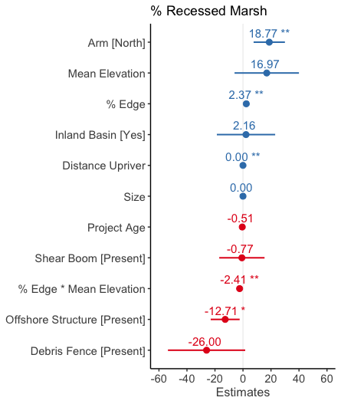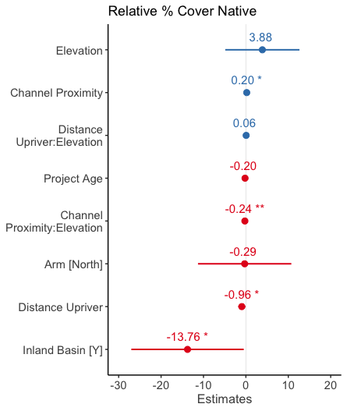

Figure 3. Model coefficients for fixed effects included in percent recessed marsh (left) and relative percent cover native (right) models. Coefficients right of 0 (blue) indicate positive effects, and those located to the left of zero (red), indicate negative effects. Within each panel, coefficients are ordered from the most to least positive effects. Coefficients with statistically significant effects are noted with asterisks (p < .001 ‘***’, .01 ‘**’, .05 ‘*’). Error bars represent 95% confidence intervals.

## Relative % Cover of Native Species in Created Marshes

A total of 1270 vegetation plots sampled in created marshes were included in this analysis, with 857 plots sampled at 51 sites in 2015, and 413 plots sampled at 28 sites in 2021 (Fig. 4). Sampling effort was similar among years in created marshes, averaging 16.8 plots/site in 2015 and 14.8 plots/site in 2021. Relative percent cover of native species ranged from 0–100% in the created marsh sample plots, averaging 60.2% (SD = 35.8%).

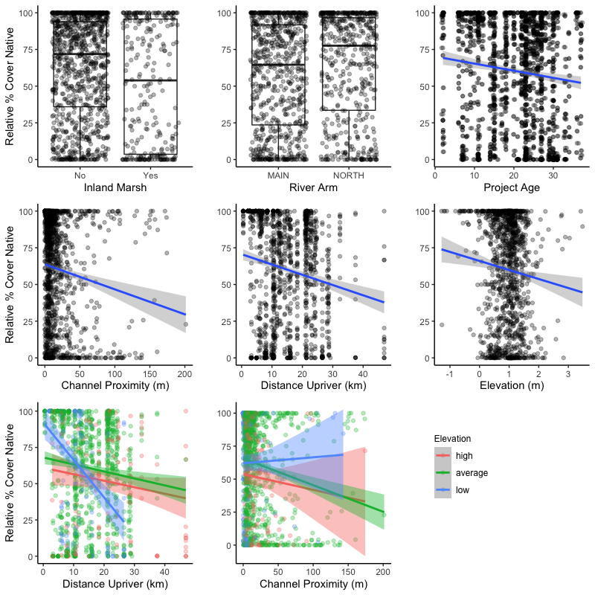

Figure 4. Scatter plots and box and whisker plots displaying the distribution of data for each covariate used to model relative percent cover of native species per plot. Box and whisker median values are shown by the middle horizontal line of each box plot, separating the upper box (2nd quartile) and lower box (3rd quartile) Percent edge habitat and distance upriver were entered as interacting terms with elevation, which we have visualized by showing the interactions relative to low (< [mean - σ]), average (mean), and high (> [mean + σ]) maximum elevation values (centre bottom).

Among model main effects, only channel proximity (*p* = .032) had a significant positive effect on native dominance (marginal *R*2 = 0.071, conditional *R*2= 0.41; Fig. 3). The significant interaction between channel proximity and elevation suggests that mid to high elevation marshes generally experience more significant declines in native dominance with distance from channels (*p* = .002; Fig. 4). Distance upriver (*p* = .027) and plots located in inland basins (*p* = .044) had more substantial negative effects, with plots averaging declines of nearly 1% per kilometer upriver, and 14% in inland basins. Project age, river arm and elevation had no significant effect. Though no significant interaction was observed between distance upriver and elevation, there are indications that low elevation marshes may experience greater declines in native dominance with distance upriver than mid to high elevation marshes.

## Species Richness of Fraser Estuary Marshes

A total of 1740 sample plots were included in richness models, with 1270 originating from 79 created marshes (see 3.2 for more details), and 470 from 16 reference marshes (Fig. 5). Sampling effort was similar in compensation sites between years, however reference sites were sampled with greater intensity in 2015, averaging 42.0 plots in 7 sites, versus 19.6 plots in 9 sites in 2021. Native richness ranged from 0–13 species/plot, averaging 3.6 species/plot (SD = 2.4). Elevation (*p* <.001), distance upriver (*p =* .028), and channel proximity had significant positive effects on native richness, with an average increase of 0.8 native species/plot with each meter elevation, 0.06 native species/plot with each kilometer upriver, and 0.01 species/plot per meter distance from channel (marginal *R2*= 0.641, conditional *R*2= 0.444; Fig. 6). The placement of a plot in a reference site had no significant effect, nor did river arm or an interaction between distance upriver and elevation.

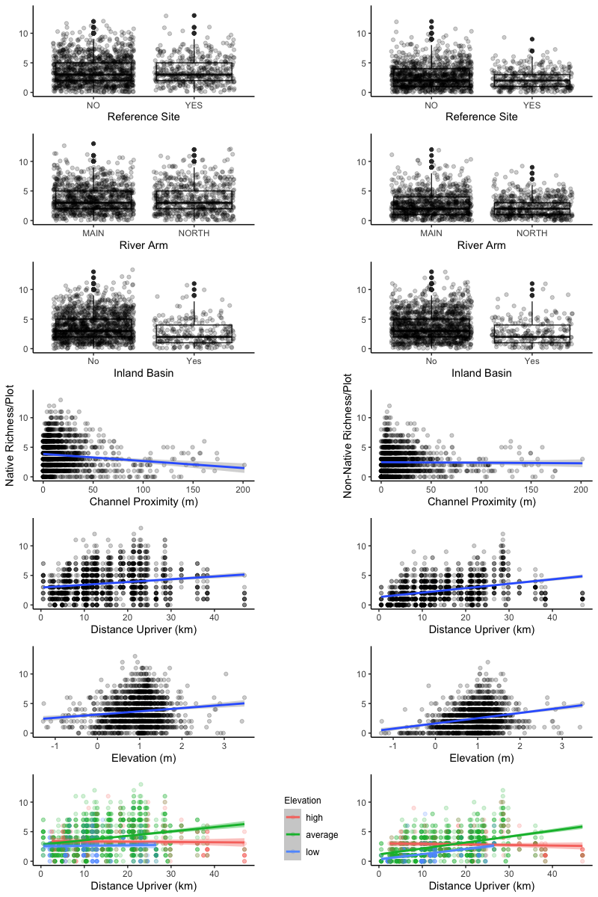Figure 5. Scatter plots and box and whisker plots displaying the distribution of data for each covariate used to model native richness/plot (left) and non-native richness/plot (right). Box and whisker median values are shown by the middle horizontal line of each box plot, separating the upper box (2nd quartile) and lower box (3rd quartile) Percent edge habitat and distance upriver were entered as interacting terms with elevation, which we have visualized by showing the interactions relative to low (< [mean - σ]), average (mean), and high (> [mean + σ]) maximum elevation values (centre bottom).

Non-native richness ranged from 0–12 species/plot, averaging 2.5 (SD = 1.9) over the study area. Similar to native richness, non-native richness was correlated with elevation (*p* < .001), distance upriver (*p* <.001), and proximity to channel (*p* = .007; marginal *R*2 = 0.164, conditional *R*2 = 0.522; Fig. 6). The placement of plots in inland basins, the North Arm or in reference sites had no significant effect on non-native richness, though there are indications that plots in reference sites may be prone to lower non-native richness than those of created marshes (*p* = .084). A significant interaction was found between distance upriver and elevation (*p* = .002), indicating that the effects of distance upriver on non-native diversity is dependent on elevation. Average and low elevation marshes appear to increase in richness with distance upriver, whereas high elevation marshes experience minimal change. Though not statistically significant, similar trends were observed with the native richness model (see Fig. 5 for all visualized interactions).

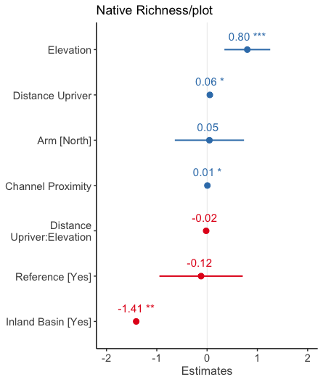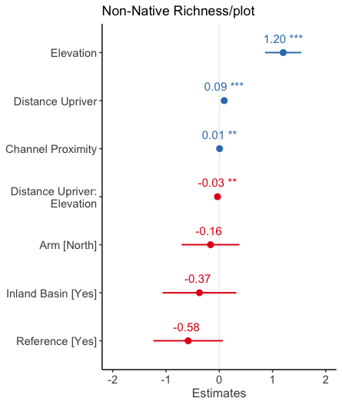

Figure 6. Model coefficients for fixed effects included in native richness (left) and non-native richness (right) models. Coefficients right of 0 (blue) indicate positive effects, and those located to the left of zero (red), indicate negative effects. Within each panel, coefficients are ordered from the most to least positive effects. Coefficients with statistically significant effects are noted with asterisks (p < .001 ‘***’, .01 ‘**’, .05 ‘*’). Error bars represent 95% confidence intervals.

# Discussion

## Marsh Recession Mitigation Strategies

We found that marsh recession is frequent in created marshes of the FRE, occurring in 39% of projects included in this study, and representing about 22,946 m2 of total recessed marsh (see Appendix B for examples). Similar to recession occurring in the natural marshes of the outer estuary, isolating a lone driver for these losses is unlikely, as there are presumably several contributing and interacting factors leading to plant mortality (Balke 2017; Marijnissen & Stefan 2017). Wave erosion, herbivory by Canada Geese *(Branta canadensis*)*,* altered sediment processes, sea-level rise, and shading by bridge structures or neighbouring riparian vegetation are all possible causes, and warrant further investigation.

Offshore structures, which included log storage booms and dock structures, were negatively correlated with recession, suggesting they are at least partially mitigating the biotic and/or abiotic drivers of marsh loss. As log storage booms are often installed to reduce the energy of boat wake (Adams & Williams 2004), this could indicate that boat wake is a driver of recession. Further evidence of wake impacts may be the difference between Main Arm and North Arm sites, with North Arm sites averaging 18% more recessed area per site. Though both river arms support substantial boat traffic, the North Arm channel is narrower throughout, thus allowing less time and distance for wave energy to dissipate before reaching the shore. The negative effect of debris fences on recession may also be interpreted as evidence of wave erosion, as these fences generally occur at the entrance to highly protected inland channels and lagoons.

Reduced recession in highly protected inland marshes may also point to herbivory by Canada Geese as a contributing factor. Canada Geese have already been attributed to planting mortality and failure in several tidal marshes in the FRE (Kistritz 1995; Adams & Williams 2004), and sedge marsh losses in nearby estuaries (Crandell 2001; Dawe et al. 2015). Herbivory was noted in more than half of the created marshes visited in this study, with high (i.e., community altering) impacts observed in 14%, moderate (i.e., widespread clipping) in 15%, and low (i.e., occasional clipping) in 24% of sites (Fig. 7). Inland marsh designs may offer a solution to herbivory (see inset, p. 8), as sites are generally less accessible to Canada Geese, who rely on tidal flats and large channels to enter marshes, and generally avoid enclosed areas where tall riparian vegetation or human structures obscure their vision. Our data support this hypothesis, as 9 out of 13 (69%) of inland sites visited in our surveys had no visible sign of herbivory and none were graded as moderate or high intensity. Maximum *C. lyngbyei* leaf height data from vegetation plots also appear to be slightly higher in inland sites than those exposed to river channels (Fig. 7).

Figure 7. Bar plot (left) showing the number of created marsh sites (inland versus non-inland) per grazing intensity class, based on field notes and photos taken in 2015 by Lievesley at al. (2016) and this study (2021) Classes were defined as “None” (no evidence of herbivory), “Low” (occasional clipped plants), “Moderate” (widespread clipping), and “High” (community altering). Boxplot (right) showing the maximum Lyngbye’s sedge height per plot in inland sites versus non-inland created marshes.

Unexpectedly, we found that project size did not have a significant effect on marsh recession, suggesting that project size alone does not equate to recession resilience. This finding fails to support the prevailing opinion that larger projects are more resilient to external stressors due to their size. Instead, we found that proportion of edge habitat had greater influence, and was positively correlated with recession, particularly in low to mid elevation marshes. These findings do not disqualify large-scale projects, as large projects can have smaller edge to area ratios thus reducing edge effects and providing many other values. This finding does, however, highlight the need to incorporate edge effects in project design.

## Edge Effects & Sea-level Rise

Low- and mid-elevation created marshes with a large percentage of edge habitat experienced more marsh recession than high marshes, indicating that elevation is linked to the intensity of edge effects. This is of particular concern in a coastal context where sea levels are estimated to increase 0.5 – 2.5 m by the year 2100 (Ausenco Sandwell 2011; Sweet et al. 2017). Though accretionary processes can mitigate the loss of marsh habitat in modest sea-level rise scenarios, low marsh erosion and the bounding of the high marsh with hard infrastructure would likely still result in net marsh loss (Kirwan & Murray 2008). Increases in ocean heights may amplify edge effects by exposing marshes to wake and river flow energy for longer durations, increasing grazing access by Canada Geese, and decreasing plant community resilience through increased inundation and salinity stress.

Low elevation was also correlated with significantly lower native and non-native species richness, a pattern common to estuaries around the world (Engels & Jensen 2009). Native species richness plays an important role in stabilizing the community-level effects of environmental fluctuations (Loreau & de Mazancourt 2013), and may be critical for the persistence of tidal marshes in the context of large-scale environmental change. There was no observed difference in native or non-native species richness between created marshes and reference marshes, indicating they are similarly equipped for environmental change. However, the pattern of low richness at the margins of tidal marshes could be problematic, as the pool of species, and therefore diversity of morphological and functional traits facing these environmental extremes, is minimal. We recommend that experiments be conducted on these specialists to further quantify their resilience to change. Experimental translocation of native species within the estuary may also be considered, as the current distribution of native species is likely not indicative of what is best adapted to future conditions.

Coastal squeeze is a term used to describe the loss of intertidal habitat due to the low water mark migrating landward due to sea-level rise, while the high water mark is fixed by a dike or other defence infrastructure (Loreau & de Mazancourt 2013). We propose another form of coastal squeeze may also occur, as rising sea levels force the retreat of native marsh communities into high elevations dominated by established invasive species (Fig. 8). This is evidenced by our richness data. First, the distribution of our richness data, though positively correlated with elevation, appears to be symmetric and unimodal, peaking around 1 m elevation (Fig. 5). This suggests that the species-rich elevations of the estuary are currently constrained by environmental stress at low elevations, and another, unknown factor in upper elevations. Second, we found that richness generally increased with distance upriver, but this trend was not observed in high elevations, which appear to remain stable throughout the estuary. Though only observational, we believe that reed canarygrass (*Phalaris arundinacea*) is likely this biotic barrier, as (1) we have observed it as a dominant species throughout the estuary, particularly in mid- to high-elevation marshes where salinity and tidal stresses are minimal, (2) only it and invasive cattail are known to form dense monocultures among four key invasive plant species of the estuary (Fig. 9), and (3) it may be better-adapted to higher elevations because unlike the other invasive plants it is not an obligate wetland species (Lichvar et al. 2012) and can be found in upland and disturbed environments. *P. arundinacea* forms dense, rhizomatous mats and is tolerant of periodic flooding (Klimešová 1994; Kercher & Zedler 2004). In one *in situ* experiment, prolonged inundation under more than 0.85 m of water was required to reduce *P. arundinacea* cover by 6.8% (Jenkins et al. 2008). Though further investigation is warranted, the periodic flooding of a rising tidal cycle will likely not be sufficient to allow for the landward encroachment of native marsh species into well-established *P. arundinacea* stands.

Figure 8. Illustration of the biotic coastal squeeze proposed by the authors. Reed canarygrass is present in many of the high marshes of the Fraser Estuary (A) and is likely resilient to environmental change once established. As rising sea levels force the retreat of native marshes, their low competitive ability, and inability to move upslope may lead to their disappearance (B).

## Invasive Species

Relative percent cover of native species decreased at a rate of about 1% per kilometre upstream, a trend that correlates with the percent frequency per site data of invasive plants in our surveys (Fig. 9). The high invasion resilience of marshes near the delta front can likely be attributed to elevated salinity and tidal stress, which exclude most competitors and facilitate the dominance of a small number of native specialists, such as common three-square bulrush (*Schoenoplectus pungens*)and Lyngbye’s sedge. Distance upriver was also correlated with increased species richness. The larger pool of species competing for more favorable upstream conditions likely drives diminishing native dominance with distance upriver. These results align with Crain et al. (2004) who found through transplant experiments that dominant saltwater specialists diminished in competition experiments as salt stress was reduced, succumbing to more competitive freshwater wetland species.

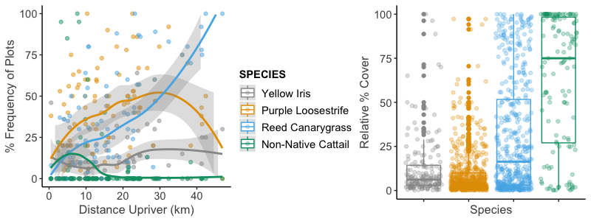

Figure 9. Scatterplot showing the percent frequency of plots of four known invasive species in the Fraser Estuary with increasing distance upriver (left) and the relative percent cover of those species, when present in a plot (right). Data were collected from created and reference marshes in the FRE by Lievesley et al. (2016) and in 2021. Loess regression lines display non-parametric trends in the data.

Invasive species that can defy these specialist-competitor interactions and successfully establish in the delta front should be of concern to managers, as they may be able to exploit the low competitive ability of sympatric natives. In the FRE, invasive plants that are most successful along the delta front are English cordgrass (*Spartina anglica*), which is not present in any of the sites included in this study, and non-native cattail, which differs from the other estuarine invasive plants in being primarily restricted to the lower 10 km of the estuary, occurring in only 15 sites (19%; Fig. 9; Stewart, 2021). Conversely, yellow flag iris (*Iris pseudacorus*), purple loosestrife, and reed canarygrass (*Phalaris arundinacea*) were found throughout the study area in 42 (53%), 66 (84%) and 56 (71%) sites, respectively. Though native dominance was generally highest near the estuary mouth, cattail-invaded sites were often outliers, with low native dominance. This may be attributed to the high displacement ability of cattail and the low competitive ability of sympatric species, as plots containing cattail averaged a relative percent cover of 68.8 (SD = 37.2%), significantly higher than any other invasive species (Fig. 9).

This trend of declining native dominance with distance upriver may be useful for managers and practitioners as they plan for invasive species in the design and maintenance of created tidal marshes. Sites constructed further upriver may require more intensive and long-term invasive species management, as they appear more vulnerable to invasion. Near the estuary mouth, managers may need to shift their attention towards non-native cattail. Stewart (2021) found that created tidal marshes in the FRE were more proportionally invaded and vulnerable to invasion than natural marshes, and suggested that design, including factors such as elevation, proximity to neighbouring infestations, and connectivity to the Fraser River may be factors. Our findings support this, as the 15 created marshes where cattail is present, 9 (60%) are inland designs, representing 69% of all inland sites in this study. Not surprisingly, inland sites were negatively correlated with native dominance, averaging 14% less native relative percent cover than non-inland sites. Managers and practitioners must therefore balance the benefits of inland site designs (as discussed in 4.1) with their potential vulnerability to cattail and other species invasions.

## Monitoring Implications

Contrary to our expectations, the age of the created marshes we surveyed did not have a significant effect on marsh recession, nor on relative percent cover of native species. The five-year monitoring period that is typical of marsh creation projects in the FRE may therefore be sufficient to predict their long-term success. This finding indicates that (1) well-designed and implemented tidal marsh creation projects that account for threats such as invasive species, wake erosion, and goose herbivory appear resilient in the long term, and (2) the success trajectory of a project should be evident not long after it is completed. Site age was not included in our richness models, as we included data from natural marshes that had no defined age. However, our reference site covariate operated as a proxy for age to a degree, as reference sites are inherently much older than created sites. Since no significant difference was observed in native and non-native richness between reference and created tidal marshes, it appears that created marshes can resemble natural marshes in their species composition and vegetation health in a relatively short amount of time, either through natural colonisation, or through propagules introduced via transplant cores from neighbouring natural marshes.

## Site Design Trade-offs

These findings have shed light on factors that play into the health of created marshes in the FRE, but they by no means provide a simple formula to ensure their success. In part this is due to the dynamic and unpredictable nature of the system, but also the complexity of building and sustaining sites that are resilient to numerous stressors simultaneously. This study has included a subset of these stressors (i.e., grazing, wave erosion, sea-level rise, invasive species), but there are numerous others that were not explored (e.g., log debris, geofluvial processes, biochemical processes). The challenge for those designing and constructing these marshes is that mitigation strategies often differ and or even conflict among stressors, and therefore design trade-offs must occur (Table 1).

|  |  |  |
| --- | --- | --- |
| **Design Element** | **Pro** | **Con** |
| Inland design | * Reduced impacts of herbivory, and river and wake erosion * Log debris can be managed through fencing structures at channel entrance | * Prone to dominance by invasive species, particularly *Typha* sp., and lower species richness * Dependent on available terrestrial habitat, which is not common * Potentially less resilient to sea-level rise due to inhibited sediment delivery processes |
| Marsh bench design | * Less susceptible to dominance by invasive species * Higher plant community diversity * Site s | * More edge habitat, therefore more susceptible to herbivory and wake erosion. |
| Low elevation | * More resilient to species invasions, as low elevations are generally more dominated by native specialists * Less susceptible to log debris accumulation * Higher value fish habitat, inundated for long periods of tidal cycle | * More susceptible to foreshore marsh recession, perhaps due to elevated exposure to grazing and erosional forces * Potentially more vulnerable to sea-level rise |
| High elevation | * More resilient to adverse edge effects, and less likely to experience recession * Potentially more resilient to sea-level rise | * Lower value fish habitat, isolated for much of tidal cycle * More prone to invasion by invasive species |

## Data limitations and Underlying Mechanisms

While these findings and interpretations provide valuable insights for restoration practitioners, there are key data limitations to consider. The covariates included in these models point to important trends in marsh recession and vegetation resilience, but we did not elucidate the mechanisms underlying these phenomena. Further study will be required to identify the true effects of these mechanisms, and to determine how best to mitigate them. Our findings indicate that wave action mitigating structures are correlated with reduced marsh recession, but further study should investigate the direct effects of wake erosion on marsh health, and the most reliable and cost-effective techniques to mitigate wake impacts. Likewise, further research is needed to identify the distribution and magnitude of goose herbivory impacts and to develop effective goose management strategies that go beyond short-term, localized mitigation.

None of our models exceeded *R*2 = 0.6, thus indicating there are likely several biotic and abiotic factors that were not included as covariates, but which could have improved model performance and accounted for much of the variation in our data. Examples of such abiotic factors include true measures of salinity and tidal prism (i.e., not inferred from distance upriver), direct measurements of wave energy impacting the created marshes, and site-level edaphic data to ascertain soil qualities. Design and implementation factors also suffered from data deficiency and incomplete records. Ideally, project design factors like planting prescriptions, geese mitigation, monitoring plans, and maintenance plans would have been included, as well as overall project cost. Our models provide useful insights, but further investigation into the successes and failures of marsh creation in the FRE is warranted.

# Conclusion

Assessments of the more than 100 marsh creation projects in the Fraser River Estuary have heretofore been restricted to qualifying success or failure. We sought to identify what factors determine marsh creation success through field sampling, remote sensing, and rigorous statistical models. We found that approximately 10% of the created marsh area we surveyed had recessed, a phenomenon that was negatively correlated with shoreline protecting structures like shear booms and offshore floating structures like log storage booms. Our findings point to wake erosion and goose herbivory as potential underlying causes of marsh recession, though further investigation into these mechanisms is warranted. Marsh recession, relative cover of native species, and native species richness were all influenced by edge effects and elevation, an important finding as sea level is projected to rise in our region. We hope that lessons from these investigations will contribute to more successful marsh creation projects and inspire further study of the underlying causes of marsh creation success and failure.

# Works Cited

Adams MA, Williams GL. 2004. Tidal marshes of the Fraser River estuary: composition, structure, and a history of marsh creation efforts to 1997. Pages 147–172 in Groulx DC, Luternauer JL, Bilderback DE, editors. Fraser River Delta, British Columbia: Issues of an Urban Estuary. Available from https://geoscan.nrcan.gc.ca/starweb/geoscan/servlet.starweb?path=geoscan/fulle.web&search1=R=215772 (accessed September 7, 2021).

Allan E, Weisser W, Weigelt A, Roscher C, Fischer M, Hillebrand H. 2011. More diverse plant communities have higher functioning over time due to turnover in complementary dominant species. Proceedings of the National Academy of Sciences **108**:17034–17039.

Alldred M, Baines SB. 2016. Effects of wetland plants on denitrification rates: a meta-analysis. Ecological Applications **26**:676–685.

Arias-Ortiz A, Oikawa PY, Carlin J, Masqué P, Shahan J, Kanneg S, Paytan A, Baldocchi DD. 2021. Tidal and Nontidal Marsh Restoration: A Trade-Off Between Carbon Sequestration, Methane Emissions, and Soil Accretion. Journal of Geophysical Research: Biogeosciences **126**:e2021JG006573.

Ausenco Sandwell. 2011. Climate Change Adaption Guidelines for Sea Dikes and Coastal Flood Hazard Land Use. Page 59. BC Ministry of Environment. Available from https://www2.gov.bc.ca/assets/gov/environment/air-land-water/water/integrated-flood-hazard-mgmt/sea_dike_guidelines.pdf.

Avenza Systems Inc. 2021. Avenza Maps. Toronto, Ontario.

Balke E. 2017. Investigating the role of elevated salinity in the recession of a large brackish marsh in the Fraser River estuary. Masters Project. Simon Fraser University & British Columbia Institute of Technology, Burnaby.

Barbier EB, Hacker SD, Kennedy C, Koch EW, Stier AC, Silliman BR. 2011. The value of estuarine and coastal ecosystem services. Ecological Monographs **81**:169–193.

Bartoń K. 2020. MuMIn: Multi-Model Inference. Available from https://CRAN.R-project.org/package=MuMIn.

Bates D, Mächler M, Bolker B, Walker S. 2015. Fitting Linear Mixed-Effects Models Using **lme4**. Journal of Statistical Software **67**. Available from http://www.jstatsoft.org/v67/i01/ (accessed September 7, 2021).

Bottom DL, Simenstad CA, Burke J, Baptista AM, Jay DA. 2005. Salmon at river’s end: the role of the estuary in the decline and recovery of Columbia River salmon. Page 246. NOAA Tech. Memo NMFS-NWFSC-68. U.S. Dept. Commer. Available from https://pdxscholar.library.pdx.edu/cgi/viewcontent.cgi?article=1023&context=cengin_fac (accessed October 20, 2021).

Boyle CA. 1997. Changes in Land Cover and Subsequent Effects on Lower Fraser Basin Ecosystems from 1827 to 1990. Environmental Management **21**:185–196.

Bradford MJ, Macdonald JS, Levings CD. 2017. Monitoring fish habitat compensation in the Pacific region: lessons from the past 30 years. Page vi + 26. 2017/033, DFO Can. Sci. Advis. Sec. Res. Doc. Fisheries and Oceans Canada, Ottawa.

Broome SW, Craft CB, Burchell MR. 2019. Tidal Marsh Creation. Pages 789–816 in Perillo GME, Wolanski E, Cahoon DR, Hopkinson CS, editors. Coastal wetlands: an integrated ecosystem approach2nd edition. Elsevier, Amsterdam.

Brophy LS, Greene CM, Hare VC, Holycross B, Lanier A, Heady WN, O’Connor K, Imaki H, Haddad T, Dana R. 2019. Insights into estuary habitat loss in the western United States using a new method for mapping maximum extent of tidal wetlands. PLOS ONE **14**:e0218558.

Butler RW, Campbell RW. 1987. The Birds of the Fraser River Delta: Populations, Ecology and International Significance. Occasional Paper **65**:1–73.

Chalifour L, Scott DC, MacDuffee M, Iacarella JC, Martin TG, Baum JK. 2019. Habitat use by juvenile salmon, other migratory fish, and resident fish species underscores the importance of estuarine habitat mosaics. Marine Ecology Progress Series **625**:145–162.

Chalifour L, Scott DC, MacDuffee M, Stark S, Dower JF, Beacham TD, Martin TG, Baum JK. 2021. Chinook salmon exhibit long-term rearing and early marine growth in the Fraser River, British Columbia, a large urban estuary. Canadian Journal of Fisheries and Aquatic Sciences **78**:539–550.

Community Mapping Network (CMN). 2021. BIEAP - FREMP Atlas. Available from https://cmnmaps.ca/dfo_fremp/ (accessed November 22, 2021).

Correa RE, Xiao K, Conrad SR, Wadnerkar PD, Wilson AM, Sanders CJ, Santos IR. 2021. Groundwater Carbon Exports Exceed Sediment Carbon Burial in a Salt Marsh. Estuaries and CoastsDOI: 10.1007/s12237-021-01021-1. Available from https://link.springer.com/10.1007/s12237-021-01021-1 (accessed December 3, 2021).

Crain CM, Silliman BR, Bertness SL, Bertness MD. 2004. Physical and Biotic Drivers of Plant Distribution Across Estuarine Salinity Gradients. Ecology **85**:2539–2549.

Crandell CJ. 2001. Effect of grazing by Branta canadensis (Canada Geese) on the fitness of Carex lyngbyei (Lyngby’s sedge) at a restored wetland in the Duwamish River Estuary. Masters Thesis. University of Washington, Seattle, WA.

Dahl TE. 1990. Wetlands losses in the United States 1780s to 1980s. Page 13. U.S. Department of the Interior, Fish and Wildlife Research. Available from https://www.fws.gov/wetlands/documents/Wetlands-Losses-in-the-United-States-1780s-to-1980s.pdf (accessed October 19, 2021).

Dawe NK, Boyd WS, Martin T, Anderson S, Wright M. 2015. Significant marsh primary production is being lost from the Campbell River estuary: another case of too many resident Canada Geese (Branta canadensis)? **25**:11.

Department of Fisheries and Oceans. 1986. Policy for the management of fish habitat. Pages 1–32. Communications Directorate, Ottawa, Ontario.

Engels JG, Jensen K. 2009. Patterns of wetland plant diversity along estuarine stress gradients of the Elbe (Germany) and Connecticut (USA) Rivers. Plant Ecology & Diversity **2**:301–311.

Fisheries and Oceans Canada. 2019. Fish and Fish Habitat Protection Policy Statement. Page 37. Ottawa.

Fitzpatrick SM, Rick TC, Erlandson JM. 2015. Recent Progress, Trends, and Developments in Island and Coastal Archaeology. The Journal of Island and Coastal Archaeology **10**:3–27.

Forysinski K. 2019. Nature-based flood protection: the contribution of tidal marsh vegetation to wave attenuation at Sturgeon Bank. Masters Thesis. University of British Columbia.

Fox J, Weisberg S. 2019. An {R} Companion to Applied RegressionThird. Sage, Thousand Oaks, California. Available from URL: https://socialsciences.mcmaster.ca/jfox/Books/Companion/.

GRASS Development Team. 2012. Geographic Resources Analysis Support System (GRASS). Open Source Geospatial Foundation. Available from http://grass.osgeo.org.

Grout JA, Levings CD, Richardson JS. 1997. Decomposition Rates of Purple Loosestrife (Lythrum salicaria) and Lyngbyei’s Sedge (Carex lyngbyei) in the Fraser River Estuary. Estuaries **20**:96–102.

Haines EB, Hanson RB. 1979. Experimental degradation of detritus made from the salt marsh plants  *Spartina alterniflora*  Loisel.,  *Salicornia virginica*  L., and  *Juncus roemerianus*  Scheele. Journal of Experimental Marine Biology and Ecology **40**:27–40.

Hoos LM, Packman GA. 1974. The Fraser River Estuary: status of environmental knowledge to 1974. Report of the Estuary Working Group, Department of the Environment, Regional Board Pacific Region. Environment Canada, Ottawa. Available from https://waves-vagues.dfo-mpo.gc.ca/Library/22723.pdf (accessed October 19, 2021).

James G, Witten D, Hastie T, Tibshirani R, editors. 2013. An introduction to statistical learning: with applications in R. Springer, New York.

James-Pirri M-J, Roman CT, Heltshe JF. 2007. Power analysis to determine sample size for monitoring vegetation change in salt marsh habitats. Wetlands Ecology and Management **15**:335–345.

Jenkins NJ, Yeakley JA, Stewart EM. 2008. First-year responses to managed flooding of lower Columbia River bottomland vegetation dominated by Phalaris arundinacea. Wetlands **28**:1018–1027.

Jessop J, Spyreas G, Pociask GE, Benson TJ, Ward MP, Kent AD, Matthews JW. 2015. Tradeoffs among ecosystem services in restored wetlands. Biological Conservation **191**:341–348.

Kennish MJ. 2002. Environmental threats and environmental future of estuaries. Environmental Conservation **29**:78–107.

Kentula ME. 2000. Perspectives on setting success criteria for wetland restoration. Ecological Engineering **15**:199–209.

Kercher SM, Zedler JB. 2004. Flood tolerance in wetland angiosperms: a comparison of invasive and noninvasive species. Aquatic Botany **80**:89–102.

Kirwan ML, Murray AB. 2008. Ecological and morphological response of brackish tidal marshland to the next century of sea level rise: Westham Island, British Columbia. Global and Planetary Change **60**:471–486.

Kistritz R, Williams G, Scott J. 1992. Inspection of Red-Coded Habitat: Fraser River Estuary Summer of 1992. Page 177. Fraser River Estuary Management Program, New Westminster, B.C. Available from http://a100.gov.bc.ca/pub/acat/documents/r43192/92_Insptn_RedCodedHabitat_1406584202267_6577808418.pdf (accessed January 27, 2022).

Kistritz RU. 1995. Habitat Compensation, Restoration and Creation in the Fraser River Estuary: Are We Achieving a No-Net-Loss of Fish Habitat? Page 70 p. plus Appendices (113 p.). Can. Tech. Rept. 2349, Fish. Aquat. Sci.

Klimešová J. 1994. The effects of timing and duration of floods on growth of young plants of Phalaris arundinacea L. and Urtica dioica L.: an experimental study. Aquatic Botany **48**:21–29.

Lee JJ. 2021. The impacts of exotic Typha on benthic invertebrate communities in the South Arm of the Fraser River Estuary. Page 41. Masters Project. Simon Fraser University & British Columbia Institute of Technology, Burnaby.

Levings CD. 2000. An Overview Assessment of Compensation and Mitigation Techniques Used to Assist Fish Habitat Management in British Columbia Estuaries. Page 7 in Knudsen EE, Steward CR, MacDonald DD, Williams JE, Reiser DW, editors. Sustainable Fisheries Management1st Edition. CRC Press, Boca Raton.

Levings CD. 2004a. Knowledge of fish ecology and its application to habitat management. Pages 213–236 in Groulx DC, Luternauer JL, Bilderback DE, editors. Fraser River Delta, British Columbia: Issues of an Urban Estuary. Available from https://geoscan.nrcan.gc.ca/starweb/geoscan/servlet.starweb?path=geoscan/fulle.web&search1=R=215810 (accessed November 24, 2021).

Levings CD. 2004b. Two decades of fish habitat restoration and bioengineering on the Fraser River Estuary, British Columbia, Canada. Pages 164–168 Oceans ’04 MTS/IEEE Techno-Ocean ’04 (IEEE Cat. No.04CH37600). IEEE, Kobe, Japan. Available from http://ieeexplore.ieee.org/document/1402912/ (accessed September 7, 2021).

Levings CD, Nishimura [ed.] DJH. 1996. Created and restored sedge marshes in the lower Fraser River and estuary: An evaluation of their functioning as fish habitat. Page 143. Canadian Technical Report 2126, Fisheries and Aquatic Sciences.

Lichvar RW, Melvin NC, Butterwick ML, Kirchner WN. 2012. National Wetland Plant List Indicator Rating Definitions. Page 14. US Army Corps of Engineers, Cold Regions Research and Engineering Laboratory.

Lievesley M, Stewart D, Knight R, Mason B. 2016. Assessing Habitat Compensation and Examining Limitations to Native Plant Establishment in the Lower Fraser River Estuary. Page 63.

Loreau M, de Mazancourt C. 2013. Biodiversity and ecosystem stability: a synthesis of underlying mechanisms. Ecology Letters **16**:106–115.

Magnusson A, Hilborn R. 2003. Estuarine influence on survival rates of coho (Oncorhynchus kisutch) and chinook salmon (Oncorhynchus tshawytscha) released from hatcheries on the U.S. Pacific coast. Estuaries **26**:1094–1103.

Marijnissen R, Stefan A. 2017. Marsh Recession and Erosion study of the Fraser Delta, B.C., Canada from Historic Satellite Imagery. Communications on Hydraulic and Geotechnical Engineering **2017–1**:59.

Naeem S. 1998. Species Redundancy and Ecosystem Reliability. Conservation Biology **12**:7.

Nakagawa S, Schielzeth H. 2013. A general and simple method for obtaining *R* 2 from generalized linear mixed-effects models. Methods in Ecology and Evolution **4**:133–142.

O’Meara TA, Hillman JR, Thrush SF. 2017. Rising tides, cumulative impacts and cascading changes to estuarine ecosystem functions. Scientific Reports **7**:10218.

Peterson CH, Able KW, DeJong CF, Piehler MF, Simenstad CA, Zedler JB. 2008. Chapter 4 Practical Proxies for Tidal Marsh Ecosystem Services. Pages 221–266 Advances in Marine Biology. Elsevier. Available from https://linkinghub.elsevier.com/retrieve/pii/S0065288108000047 (accessed November 11, 2021).

Pontee N. 2013. Defining coastal squeeze: A discussion. Ocean & Coastal Management **84**:204–207.

QGIS Development Team. 2021. QGIS Geographic Information System. QGIS Geographic Information System.

R Core Team. 2021. R: A language and environment for statistical computing. R Foundation for Statistical Computing, Vienna, Austria. Available from https://www.R-project.org/.

Small C, Nichols RJ. 2003. A Global Analysis of Human Settlement in Coastal Zones. Journal of Coastal Research **19**:17.

Stewart D. 2021. Undetected but widespread: the cryptic invasion of non-native cattail (Typha) in the Fraser River Estuary. Masters Thesis. University of British Columbia, Vancouver.

Sutherland TF, Elner RW, O’Neill JD. 2013. Roberts Bank: Ecological crucible of the Fraser River estuary. Progress in Oceanography **115**:171–180.

Sweet WV, Kopp R, Weaver CP, Obeysekera J, Horton RM, Thieler ER, Zervas CE. 2017. Global and regional sea level rise scenarios for the United StatesDOI: 10.7289/V5/TR-NOS-COOPS-083. U.S. Department of Commerce, National Oceanic and Atmospheric Administration, National Ocean Service, Center for Operational Oceanographic Products and Services. Available from https://repository.library.noaa.gov/view/noaa/18399 (accessed December 10, 2021).

Tilman D. 1997. Community invasibility, recruitment, limitation, and grassland biodiversity. Ecology **78**:81–92.

Vitousek PM, Aber JD, Howarth RW, Likens GE, Matson PA, Schindler DW, Schlesinger WH, Tilman DG. 1997. Human alteration of the global nitrogen cycle: sources and consequences. Ecological Applications **7**:737–750.

Zedler JB, Callaway JC. 2000. Evaluating the progress of engineered tidal wetlands. Ecological Engineering **15**:211–225.

Zedler JB, Kercher S. 2004. Causes and Consequences of Invasive Plants in Wetlands: Opportunities, Opportunists, and Outcomes. Critical Reviews in Plant Sciences **23**:431–452.

# Appendix A: Reference Marsh Descriptions

|  |  |  |  |  |  |  |
| --- | --- | --- | --- | --- | --- | --- |
| **ID** | **Year Sampled** | **UTM** | **Location** | **Elevation (m)**  **(min, max, avg., stdev)** | **Saltwater Influenced** | **Site Description** |
| REF-03 | 2021 | 10 U 517665 5452318 | Confluence of Pitt River and Fraser Main Arm, Pitt Meadows | 0.74, 2.18, 1.57, 0.18 | no | Exposed marsh bench located across the channel from Douglas Island. Pilings are present, but log storage has been minimal in adjacent channel in recent decades. Foreshore varies from steep cutbank to gradual transition to mudflat. |
| REF-04 | 2021 | 10 U 515483 5452122 | NW corner of Douglas Island, Fraser Main Arm | 0.45, 2.19, 1.40, 0.26 | no | Exposed marsh bench located on the NW corner of Douglas Island (managed by Metro Vancouver Regional District). Pilings are present, but log storage has been minimal in adjacent channel in recent decades. Foreshore is a gradual slope into the subtidal. |
| REF-05 | 2021 | 10 U 508902 5452128 | NE corner of Sapperton Bar, Fraser Main Arm | 0.49, 1.71, 1.33, 0.23 | no | Exposed marsh on a recently vegetated sandbar (<20 years old). The marsh accreted and colonised naturally, likely due to reduced water flow from extensive log storage in the vicinity. Site is protected by log storage for nearly all of the year. |
| REF-07 | 2021 | 10 U 502812 5446405 | Northern edge of Annacis Island, Annacis Channel | 0.06, 1.71, 1.10, 0.26 | yes | Exposed marsh bench with undulating topography, including a backshore channel that flows to the southwest. The site is protected by log storage booms for much of the year. Foreshore varies from small cutbank to gradual slope. |
| REF-09 | 2021 | 10 U 498779 5443907 | Northern edge of Tilbury Island, Fraser Main Arm | -0.03, 2.58, 1.14, 0.39 | yes | Embayed marsh enclosed by natural (?) sand berm to the north. No log pilings or foreshore protection present. Foreshore is a natural slope. |
| REF-11 | 2021 | 10 U 494275 5440327 | SW corner of Deas Island, Deas Slough | -0.61, 1.76, 0.78, 0.54 | yes | Marsh bench with gradual foreshore slope. Site is protected from erosional forces of the Fraser Main Arm but is exposed to regular recreational boat activity from neighbouring marina. |
| REF-13 | 2021 | 10 U 490916 5436888 | East bank of Canoe Pass, Port Guichon, Delta | -0.23, 2.13, 1.36, 0.40 | yes | Exposed marsh bench with gradual foreshore slope. The site is exposed and unprotected, but occurs in Canoe Pass, where boat traffic and erosional river flows are reduced. |
| REF-14 | 2021 | 10 U 488838 5440112 | South bank of Lulu Island, upstream of Shady Island | -0.74, 2.15, 0.86, 0.36 | yes | Marsh bench located immediately upstream of Shady Island. Site may be somewhat protected by debris deflection boom located immediately south. Foreshore is a gradual slope. |
| REF-17 | 2021 | 10 U 486897 5447333 | South bank of Sea Island, Fraser River Middle Arm | -0.78, 3.41, 1.31, 0.59 | yes | Marsh bench located upstream of Swishwash Island. Site is unprotected from wake and river erosion, which is likely reduced in the Middle Arm. Foreshore is a gradual slope into the subtidal. |
| REF-02-2015 | 2015 | 10 U 494560 5449859 | North bank of Lulu Island,  Fraser River North Arm | 0.74, 2.18, 1.57, 0.18 | yes | Marsh bench located on the north bank of Lulu Island, immediately across from Mitchell Island. Foreshore is primarily a cutbank with intertidal mudflat below. Site is regularly protected by log storage booms. |
| REF-03-2015 | 2015 | 10 U 488544 5450610 | North bank of Sea Island, Fraser River North Arm | 0.74, 2.18, 1.57, 0.18 | yes | Marsh bench located upstream of McDonald Beach Park, Sea Island. Foreshore is a cutbank, with intertidal mudflat below. Barges are occasionally moored immediately downstream, but site is generally unprotected from wave and current erosion. |
| REF-05-2015 | 2015 | 10 U 489567 5448239 | SE bank of Sea Island, Fraser River Middle Arm | -0.22, 2.96, 0.79, 0.35 | yes | Slightly embayed marsh located immediately downstream of Moray Bridge. Foreshore is a gradual transition to mudflat. Two major drainage channels bisect the site. |
| REF-09-2015 | 2015 | 10 U 493041 5437700 | SW corner of Ladner Marsh, near entrance to Ladner Slough | -0.03, 2.58, 1.14, 0.39 | yes | Exposed marsh bench with a gradually sloped foreshore. Site is not protected but is isolated from the wake and current erosion of the Main Arm. Located in South Arm Marshes Wildlife Management Area. |
| REF-10-2015 | 2015 | 10 U 496782 5442394 | SW corner of Tilbury Island, near entrance to Tilbury Slough | -0.38, 2.06, 1.04, 0.28 | yes | Unprotected marsh bench located on SW Tilbury Island. Foreshore is a gradual transition to intertidal mudflat. |
| REF-11-2015 | 2015 | 10 U 504826 5447809 | North bank of Annacis Island, Annacis Channel | 0.31, 3.00, 1.04, 0.28 | yes | Site is located immediately downstream of Derwent Way Bridge. Foreshore is a gradual transition to intertidal mudflat. Site is not protected from wave/current erosion, but Annacis Channel experiences less wake/erosion than major channels. |
| REF-12-2015 | 2015 | 10 U 501934 5445270 | SW corner of Annacis Island, Fraser Main Arm | -0.19, 1.93, 1.13 ,0.19 | Yes | Exposed marsh bench with a combination of cutbank and gradually sloped foreshore. Site is intermittently protected from wave erosion by moored barges. No major channels present. |

# Appendix B: Photo Examples of Marsh Recession

# A picture containing outdoor, sky, water, grass Description automatically generatedA picture containing outdoor, sky, ground Description automatically generatedA picture containing grass, outdoor, tree, building Description automatically generatedA picture containing tree, outdoor, sky, plant Description automatically generatedAppendix C: Photo Examples of Inland Marshes

Photo B1. Photos of sites containing recessed marsh, based on the definitions of this study. Project boundaries are displayed with red lines, and marsh extent with yellow. Areas between the red and yellow lines were classified as recessed. Photos taken by D. Stewart on and 6 May (top) and 31 May (bottom) 2021.

Photo C1. Photos of inland marsh designs. Note the debris fence located at the marsh outflow in the top image, and the engineered drainage channel in the bottom image. Photos taken by R. Ingham on and 22 July (top) and 24 June (bottom) 2021.

# Appendix D. Outcome Variables and Predictor Covariates

# 

Table D1. Quantitative and qualitative site-level and plot-level characteristics were generated for each surveyed compensation site, including both numeric and categorical data.

|  |  |  |
| --- | --- | --- |
|  | **Characteristic** | **Description** |
| **Outcome Variables** | Percent Recessed Marsh | The proportion of the intended marsh area that was no longer vegetated at the time of sampling. Based on field mapping. |
| Relative Percent Native | The proportion of the vegetated percent cover represented by native species. |
| Richness Per Plot | The number of unique native and non-native species in a plot. |
| **Predictor Covariates** | Elevation | Elevation derived from a publicly available LiDAR dataset (GeoBC, 2021). For the marsh recession model, site-level mean elevation was used. For the relative percent native and native richness models, single point plot-level elevation was used. |
| Distance Upriver | The channel distance from a standardized line across the Fraser delta front to each site or plot in kilometres   (See supplemental materials) |
| Arm | Indicates which arm of the Fraser River the marsh occurs in, either the North Arm or the Main Arm (a.k.a. South Arm). |
| Channel Proximity | The least distance from a plot centre to a major channel, measured using the GRASS toolbox in QGIS (GRASS 7.8.6; QGIS 3.20). |
| Reference | Indicates whether the site is a created marsh or a reference (natural) marsh. |
| Inland Basin | Distinguishes between inland created marshes and those directly on the river edge, exposed to riverine forces. |
| Project Age | Years since project completion at time of sampling. |
| Percent Edge | The proportion of a project area that is within 5 m of the channel edge, measured using QGIS measurement tools. |
| Size | The total project area in m2 |
| Shear Boom | Indicates whether a functioning shear boom shore protection structure was in place at time of sampling. |
| Offshore Structure | Indicates whether other offshore structures like docks, log storage booms, etc., are present as these could also mitigate wave energy. |
| Log Fence | Indicates the presence of a debris control structure, typically placed at the front of protected inland basin designs. |

# Appendix E. Marsh Recession Model Visualizations

Figure E1. Plots displaying how the expected dependent variable (% mudflat) changes as a function of each model predictor (x-axis), while all other model variables are held fixed. The expected value is displayed with the blue line, 95% confidence interval for the expected value with the grey band, and partial residuals with red dots (bottom right exempt). This and all subsequent plots in Appendices C-F were created using visreg package in R (visreg, ‘visreg’ package; Breheny & Burchett 2017)

Figure E2. Cross sectional plot displaying the fit of a model with an interaction between % edge habitat and elevation on % recessed marsh. Continuous elevation data are placed into one of three cross-sections: 10th percentile (red), 50th percentile (green), and 90th percentile (blue). The expected value is displayed by regression lines, surrounded by 95% confidence intervals. Positive and negative residuals are located on the top and bottom axes.

# Appendix F. Relative % Cover Native Model Visualizations

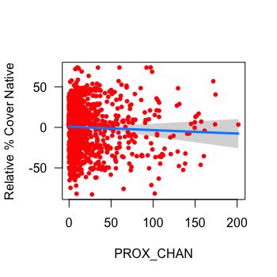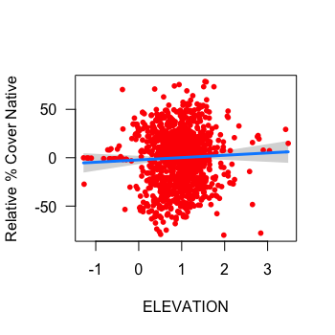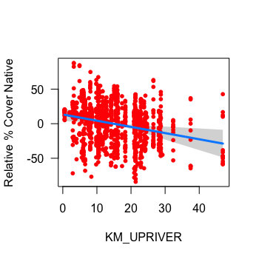

Figure F1. Plots displaying how relative % cover of native species changes as a function of each model predictor (x-axis), while all other model variables are held fixed. The expected value is displayed with the blue line, 95% confidence interval for the expected value with the grey band, and partial residuals with red dots (bottom right exempt).

Figure F2. Cross sectional plots displaying the fit of a model with an interaction between % distance upriver and elevation (top) and channel proximity and elevation (bottom) on relative % cover of native species in sample plots. Continuous elevation data are placed into one of three cross-sections: 10th percentile (red), 50th percentile (green), and 90th percentile (blue). The expected value is displayed by regression lines, surrounded by 95% confidence intervals. Positive and negative residuals are located on the top and bottom axes.

# Appendix G. Native Richness Model Visualizations

# Chart, scatter chart Description automatically generatedChart, line chart Description automatically generatedChart, scatter chart Description automatically generatedChart, scatter chart Description automatically generatedChart, scatter chart Description automatically generatedChart, scatter chart Description automatically generatedChart, scatter chart Description automatically generatedChart, line chart Description automatically generatedChart, scatter chart Description automatically generatedChart, scatter chart Description automatically generatedChart, scatter chart Description automatically generatedChart, scatter chart Description automatically generatedAppendix H. Non-Native Richness Model Visualizations

Figure G1. Plots displaying how native richness changes as a function of each model predictor (x-axis), while all other model variables are held fixed. The expected value is displayed with the blue line, 95% confidence interval for the expected value with the grey band, and partial residuals with red dots (bottom right exempt).

Figure G2. Cross sectional plot displaying the fit of a model with an interaction between % distance upriver and elevation. Continuous elevation data are placed into one of three cross-sections: 10th percentile (red), 50th percentile (green), and 90th percentile (blue). The expected value is displayed by regression lines. Positive and negative residuals are located on the top and bottom axes.

Figure H2. Cross sectional plot displaying the fit of a model with an interaction between % distance upriver and elevation. Continuous elevation data are placed into one of three cross-sections: 10th percentile (red), 50th percentile (green), and 90th percentile (blue). The expected value is displayed by regression lines. Positive and negative residuals are located on the top and bottom axes.

Figure H1. Plots displaying how non-native richness changes as a function of each model predictor (x-axis), while all other model variables are held fixed. The expected value is displayed with the blue line, 95% confidence interval for the expected value with the grey band, and partial residuals with red dots (bottom right exempt).

# Appendix I. Vegetation Survey Plant List

Table I1. A complete list of macrophytes observed during 2015 and 2021 vegetation surveys with accompanying origin status (N = Native, E = Exotic, I = Invasive). For cryptic species where origin could not be determined, origin status is ‘U’.

|  |  |  |  |  |
| --- | --- | --- | --- | --- |
| **Species** | **Common Name** | **Origin** | **2015** | **2021** |
| *Achillea millefolium* | yarrow | N |  | X |
| *Agrostis capillaris* | colonial bentgrass | E | X | X |
| *Agrostis gigantea* | redtop | E | X | X |
| *Agrostis stolonifera* | creeping bentgrass | E | X | X |
| *Ajuga* sp. | unidentified ajuga | E | X |  |
| *Alisma lanceolatum* | lance-leaf water-plantain | E |  | X |
| *Alisma triviale* | water plantain | N |  | X |
| *Alisma* sp. | unidentified water plantain | U | X |  |
| *Artemesia vulgaris* | mugwort | E | X |  |
| *Athyrium filix-femina* | lady fern | N | X | X |
| *Atriplex prostrata* | creeping salt bush | E |  | X |
| *Betula pendula* | European birch | E |  | X |
| *Bidens cernua* | nodding beggarticks | N | X | X |
| *Bidens connata* | purplestem beggarticks | E | X |  |
| *Bidens tripartita* | three-parted beggarticks | E | X |  |
| *Bolboschoenus maritimus* | sea coast bulrush | N |  | X |
| *Calamagrostis canadensis* | bluejoint | N | X | X |
| *Callitriche heterophylla* | diverse-leaved water-starwort | N | X |  |
| *Callitriche hermaphroditica* | northern starwort | N | X |  |
| *Callitriche stagnalis* | water starwort | E | X | X |
| *Caltha palustris* | marsh marigold | N | X | X |
| *Calystegia sepium* | morning-glory | I |  | X |
| *Cardamine oligosperma* | little western bitter-cress | N | X |  |
| *Cardamine* sp. | bitter-cress | U | X | X |
| *Carex aquatilis* var*. dives* | Sitka sedge | N | X | X |
| *Carex cusickii* | Cusick's sedge | N | X | X |
| *Carex exsiccata* | inflated sedge | N | X |  |
| *Carex lyngbyei* | Lyngbye's sedge | N | X | X |
| *Carex obnupta* | slough sedge | N | X | X |
| *Carex scoparia* | pointed broom sedge | N | X |  |
| *Carex stipata* | prickly sedge | N | X | X |
| *Carex utriculata* | beaked sedge | N | X | X |
| *Ceratophyllum echinatum* | hornwort | N | X |  |
| *Chenopodium album* | lamb's quarters | E | X |  |
| *Clematis vitalba* | traveler's joy | I | X |  |
| *Cicuta douglasii* | western water hemlock | N | X | X |
| *Cirsium arvense* | Canada thistle | E | X | X |
| *Comarum palustre* | marsh cinquefoil | N | X | X |
| *Conzya canadensis* | horseweed | N | X |  |
| *Cotula coronopifolia* | brass buttons | E |  | X |
| *Crassula aquatica* | pigmy-weed | N | X | X |
| *Crepis tectorum* | annual hawksbeard | E | X |  |
| *Dactylis glomerata* | orchard-grass | E | X |  |
| *Daucus carota* | wild carrot | E | X |  |
| *Deschampsia cespitosa*ssp.*bringensis* | tufted hairgrass | N |  | X |
| *Distichlis spicata* | salt grass | N |  | X |
| *Echinochloa crus-galli* | large barnyard grass | E | X |  |
| *Eleocharis obtusa* | blunt spike-rush | N | X | X |
| *Eleocharis palustris* | creeping spike-rush | N | X | X |
| *Eleocharis parvula* | small spike-rush | N | X | X |
| *Elodea canadensis* | Canadian waterweed | N | X | X |
| *Elymus repens* | quackgrass | E |  | X |
| *Epilobium cilatum* | purple willowherb | N | X | X |
| *Equisetum arvense* | common horsetail | N | X | X |
| **Species** | **Common Name** | **Origin** | **2015** | **2021** |
| *Equisetum fluviatile* | swamp horsetail | N | X | X |
| *Erythranthe scouleri* | Columbia River monkey-flower | N | X |  |
| *Festuca occidentalis* | western fescue | N | X |  |
| *Festuca rubra* | red fescue | U | X |  |
| *Festuca* sp. | unidentified fescue | U | X |  |
| *Galium palustre* | marsh bedstraw | N |  | X |
| *Galium trifidum* | small bedstraw | N | X | X |
| *Geum macrophyllum* | large-leaved avens | N | X |  |
| *Glyceria elata* | tall mannagrass | N | X |  |
| *Glyceria leptostachya* | slender spiked mannagrass | N |  | X |
| *Glyceria*sp. | mannagrass | N |  | X |
| *Gnaphalium uliginosum* | marsh cudweed | E | X |  |
| *Gratiola ebracteata* | bractless hedge-hyssop | N | X | X |
| *Hieracium lachenalii* | European hawkweed | E | X |  |
| *Hordeum brachyantherum* | meadow barley | N |  | X |
| *Hypericum anagalloides* | bog St. John’s wort | N | X |  |
| *Hypericum scouleri* ssp. *scouleri* | western St. John’s wort | N | X |  |
| *Hypochaeris radicata* | hairy cat’s-ear | E | X |  |
| *Impatiens capensis* | jewelweed | E | X | X |
| *Impatiens glandulifera* | policemen's helmet | I |  | X |
| *Impatiens parviflora* | small touch-me-not | E |  | X |
| *Iris pseudacorus* | yellow-flag iris | I | X | X |
| *Isoetes echinospora* | bristle-like quillwort | N |  | X |
| *Isolepis cernua* | low clubrush | N | X |  |
| *Juncus articulatus* | jointed rush | N | X | X |
| *Juncus balticus* | Baltic rush | N | X | X |
| *Juncus bolanderi* | Bolander’s rush | N | X |  |
| *Juncus effusus* | common rush | N | X | X |
| *Juncus gerardii* | salt-marsh rush | E |  | X |
| *Juncus oxymeris* | pointed rush | N | X | X |
| *Juncus supiniformis* | spreading rush | N | X |  |
| *Juncus tenuis* | slender rush | N | X | X |
| *Lactua serriola* | prickly lettuce | E | X |  |
| *Lapsana communis* | nipplewort | E | X |  |
| *Lathyrus palustris* | marsh pea | N | X | X |
| *Leersia oryzoides* | rice cutgrass | N |  | X |
| *Lemna sp.* | duckweed | N |  | X |
| *Leymus mollis* | dunegrass | N |  | X |
| *Lilaeopsis occidentalis* | western lilaeopsis | N | X | X |
| *Limosella aquatica* | water mudwort | N | X | X |
| *Lolium perenne* | perennial ryegrass | E | X |  |
| *Lotus corniculatus* | common bird's-foot trefoil | E | X | X |
| *Lotus pedunculatus* | stalked bird’s-foot trefoil | E | X |  |
| *Ludwigia palustris* | water purslane | N | X | X |
| *Lycopus americanus* | American bugleweed | N | X |  |
| *Lycopus europaeus* | European horehound | E |  | X |
| *Lycopus* sp. | horehound | U | X |  |
| *Lysichiton americanus* | skunk cabbage | N | X | X |
| *Lysimachia maritima* | sea milkwort | N | X |  |
| *Lysimachia nummularia* | creeping jenny | E | X | X |
| *Lysimachia terrestris* | bog loosestrife | E | X | X |
| *Lysimacia thyrsiflora* | tufted loosestrife | N | X | X |
| *Lysimachia vulgaris* | yellow loosestrife | E |  | X |
| *Lythrum salicaria* | purple loosestrife | I | X | X |
| *Lythrum portula* | European water-purslane | E | X |  |
| *Melilotus alba* | white sweet-clover | E | X |  |
| *Mentha aquatica* | water mint | E | X | X |
| *Mentha canadensis* | field mint | N | X | X |
| *Mentha* x*piperata* | peppermint | E |  | X |
| *Mentha spicata* | spearmint | E |  | X |
| **Species** | **Common Name** | **Origin** | **2015** | **2021** |
| *Menyanthes trifoliata* | buckbean | N | X | X |
| *Mimulus gutattus* | yellow monkey-flower | N |  | X |
| *Bryophyta* | unidentified moss | U |  | X |
| *Myosotis scorpioides* | European forget-me-not | E | X | X |
| *Myrica gale* | sweet gale | N |  | X |
| *Myriophyllum hippuroides* | western water-milfoil | N |  | X |
| *Myriophyllum ussuriense* | Ussurian water-milfoil | N | X |  |
| *Najas flexilis* | wavy water nymph | N | X |  |
| *Nasturtium officinale* | common watercress | E | X |  |
| *Oenanthe sarmentosa* | water parsley | N | X | X |
| *Oxalis corniculata* | yellow oxalis | E | X |  |
| *Persicaria hydropiper* | marshpepper smartweed | E | X |  |
| *Persicaria hydropiperoides* | water-pepper | N | X |  |
| *Persicaria lapathifolia* | willow weed | N | X |  |
| *Persicara minor* | Asian knotweed | E | X |  |
| *Persicaria*sp. | unidentified smartweed | U | X | X |
| *Phalarus arundinacea* | reed canary grass | I | X | X |
| *Plantago lanceolata* | ribwort plantain | E | X | X |
| *Plantago major* | common plantain | E | X | X |
| *Poa annua* | annual bluegrass | E | X | X |
| *Poa pratensis* | Kentucky bluegrass | U | X | X |
| *Poa trivalis* | rough bluegrass | E | X |  |
| *Poa* sp. | bluegrass | E | X |  |
| *Poaceae* | unidentified grasses | U |  | X |
| *Polygonum aviculare* | common knotgrass | E |  | X |
| *Populus balsamifera* | black cottonwood | N | X |  |
| *Potamogeton foliosus* | leafy pondweed | N |  | X |
| *Potamogeton natans* | floating pondweed | N | X | X |
| *Potamogeton pusillus* | small pondweed | N | X |  |
| *Potentilla anserina* | silverweed | N | X | X |
| *Potentilla egedii* | coast silverweed | N | X |  |
| *Prunella vulgaris* ssp. *vulgaris* | self-heal | E | X |  |
| *Ranunculus flammula* | lesser spearwort | N | X |  |
| *Ranunculus occidentalis* | western buttercup | N |  | X |
| *Ranunculus repens* | creeping buttercup | E | X | X |
| *Ranunculus sceleratus* | celery-leaved buttercup | N |  | X |
| *Rorippa palustris* | yellow marshcress | N | X | X |
| *Rosa multiflora* | rambler rose | E | X |  |
| *Rosa nutkana* | Nootka rose | N | X |  |
| *Rubus armeniacus* | Himalayan blackberry | I | X | X |
| *Rumex conglomeratus* | clustered dock | E | X | X |
| *Rumex crispus* | curly dock | E |  | X |
| *Rumex occidentalis* | western dock | N | X | X |
| *Rumex salicifolius* | willow-leaved dock | N |  | X |
| *Sagittaria cuneata* | arum-leaved arrowhead | N | X |  |
| *Sagittaria latifolia* | wapato | N | X | X |
| *Sagina maxima* | coast pearlwort | N | X |  |
| *Sagina procumbens* | bird-eye pearlwort | E |  | X |
| *Salicornia pacifica* | pickleweed | N |  | X |
| *Salix lucida* | shining willow | N | X |  |
| *Salix sitchensis* | Sitka willow | N | X |  |
| *Salix* sp. | willow | N | X | X |
| *Schedonorus arundinacea* | tall fescue | E | X | X |
| *Schoenoplectus pungens* | three-squared bulrush | N | X | X |
| *Schoenoplectus tabernaemontani* | softstem bulrush | N | X | X |
| *Scirpus atrocinctus* | wool grass | N | X | X |
| *Scirpus microcarpus* | small-flowered bulrush | N | X | X |
| *Scutellaria lateriflora* | blue skullcap | N | X |  |
| *Sidalcea hendersonii* | Henderson's checker-mallow | N |  | X |
| *Sinapis alba* | white mustard | E | X |  |
| **Species** | **Common Name** | **Origin** | **2015** | **2021** |
| *Sium suave* | water parsnip | N | X | X |
| *Solanum dulcamara* | European bittersweet | E | X |  |
| *Solidago canadensis* | Canada goldenrod | N |  | X |
| *Sonchus arvensis* | sow thistle | E | X | X |
| *Soncus oleraceus* | common sow thistle | E | X |  |
| *Sparganium angustifolium* | narrow-leaved bur-reed | N | X |  |
| *Sparganium emersum* | emersed bur-reed | N | X | X |
| *Spergularia salina* | saltmarsh sand spurry | E |  | X |
| *Spiraea douglasii* | hardhack | N | X |  |
| *Symphiotrichum subspicatum* | Douglas' aster | N | X | X |
| *Tanacetum vulgare* | common tansy | I | X |  |
| *Taraxacum officinale* | common dandelion | E | X | X |
| *Trifolium pratense* | red clover | E | X |  |
| *Trifolium repens* | white clover | E |  | X |
| *Trifolium wormskioldii* | springbank clover | N | X |  |
| *Triglochin maritima* | sea arrowgrass | N | X | X |
| *Triglochin scilloides* | flowering quillwort | N | X | X |
| *Typha angustifolia* | narrowleaf cattail | I | X | X |
| *Typha* x *glauca* | hybrid cattail | I | X | X |
| *Typha latifolia* | broadleaf cattail | N | X | X |
| *Vicia cracca* | tufted vetch | E | X |  |
| *Veronica anagallis-aquatica* | water speedwell | E | X | X |
| *Veronica beccabunga* | American speedwell | N | X |  |
| *Veronica scutellata* | marsh speedwell | N | X | X |
| *Veronica serpyllifolia*var.*humifusa* | thyme-leaved speedwell | E | X |  |
| *Viola langsdorffii* | Alaska violet | N | X |  |
|  |  |  |  |  |

1. According to the Policy these losses could not occur in fish habitats with high productive capacity
2. A species or genotype introduced to a novel environment, with negative ecological, economic, or social impacts